## **1.Table Structures:**

a. Create a books table with these essential fields:

• book_id (Primary Key)

• title

• author

• borrowed_date (YYYY-MM-DD)

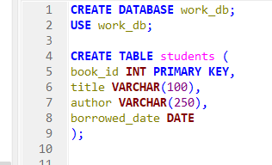

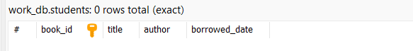

## **2. Required Operations:**

### **a. Data Entry:**

● Add at least 5 books

● Include title, author, and borrowed_date

● Use proper date format (YYYY-MM-DD)

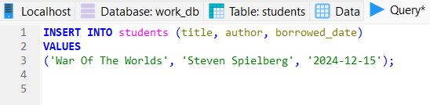

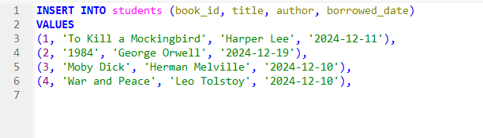

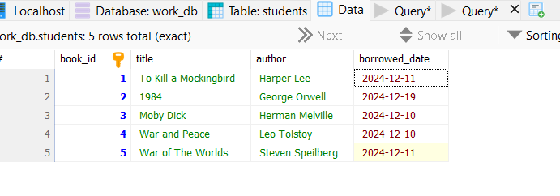

### **b. Basic Queries:**

● List all books

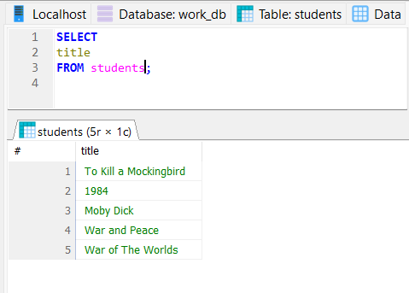

● Find books by author

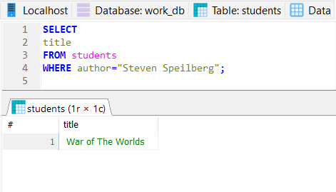

● Find books borrowed on a specific date

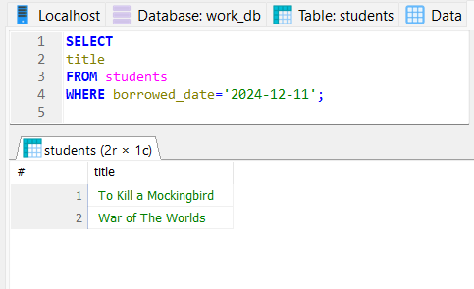

● Find books borrowed after a certain date

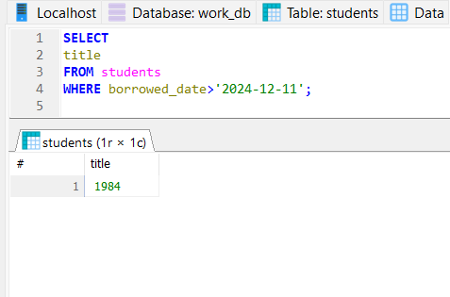

## **c. Data Manipulation:**

● Update borrowed_date

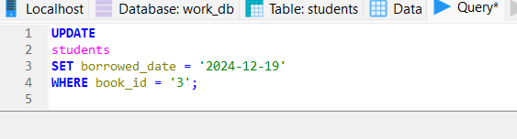

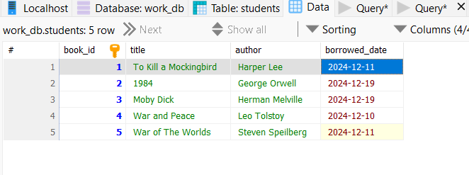

● Delete a book

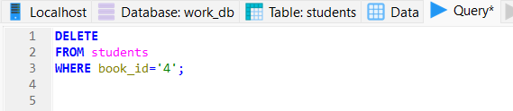

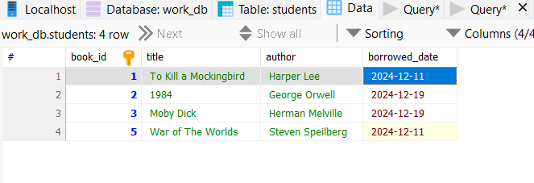

● Re-add a deleted book

